Email OTP

Flowchart
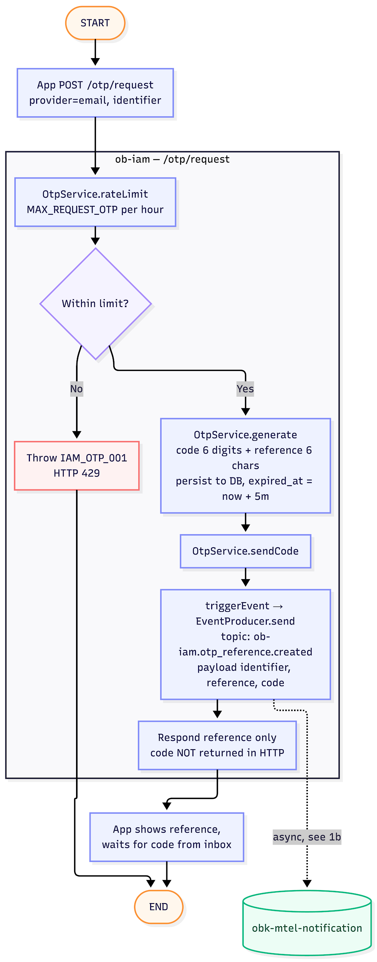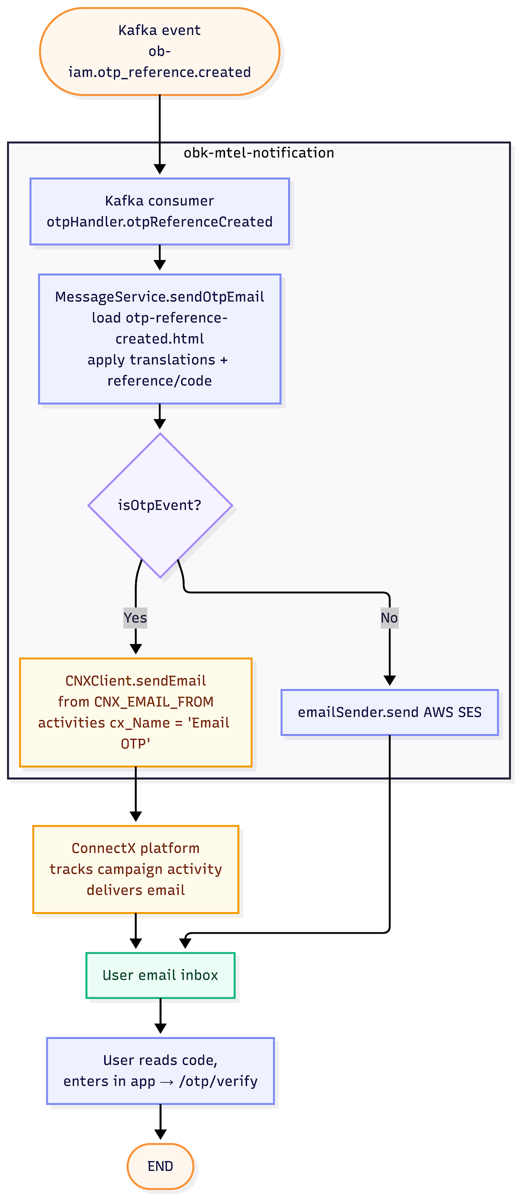

Sequence Diagram
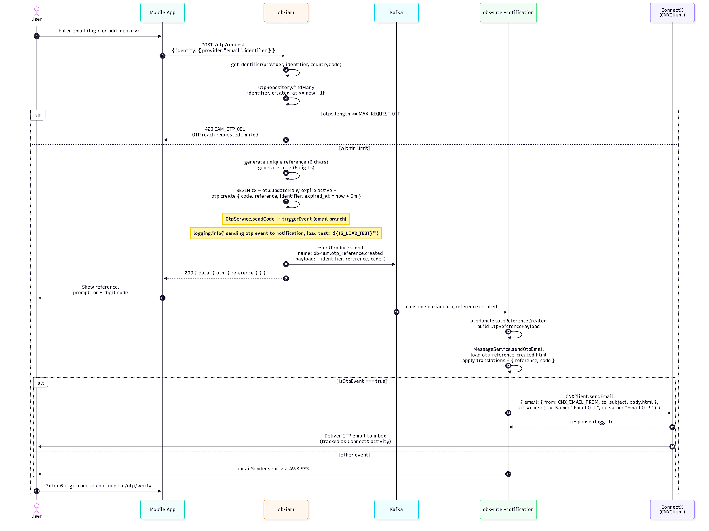

Request OTP

Overview
- Method: POST
- Path: /otp/request
- OperationId: otp.request
- Description: Generates a one-time password for the given identity (email or phone) and dispatches it via the appropriate channel. For email, IAM emits the Kafka event `ob-iam.otp_reference.created` and `ob-notification` sends the email asynchronously. The response contains only the public reference; the code is delivered out-of-band.

Request

Header Parameters
Name | Type | Required | Description
Content-Type | string | true | application/json

Body Parameters
Name | Type | Required | Description
identity | Object | true | Identity wrapper
identity.provider | string | true | `email`, `phone`, `sso`, or `keycloak`. For email OTP use `email`.
identity.identifier | string | true | Email address (lowercased server-side) or phone number.
identity.country_code | string | false | Required when `provider = phone` and identifier has no `+` prefix (e.g. `+66`). Ignored for email.

Request Example
{
"identity": {
"provider": "email",
"identifier": "user@example.com"
}
}

Success Response

HTTP 200
Field | Type | Description
data.otp.reference | string | 6-character mixed-case alphanumeric reference. Shown to the user so they can match the email they received. The code itself is NOT returned.

Success Example
{
"data": {
"otp": {
"reference": "aB3xK9"
}
}
}

Error Response

Error Object Format
Field | Type | Description
error.code | string | Application error code.
error.message | string | Human-readable error message.
error.stack | string | Stack trace (non-production only).

Error Scenario
HTTP Status | Error Code | Message | Cause
429 | IAM_OTP_001 | OTP reach requested limited | Identifier produced more than MAX_REQUEST_OTP OTPs within the last hour.
403 | IAM_OTP_005 | Invalid Whitelist Country OTP | Phone provider: country code is not in WHITELIST_COUNTRY_OTP.
500 | IAM_OTP_006 | Invalid Phone Number | Phone provider: libphonenumber-js failed to parse / validate.
500 | IAM_OTP_007 | Too many OTP requests | Phone-number cooldown (OTP_PHONE_COOLDOWN_SECONDS*) or country rate-limit (OTP_MAX_COUNTRY_RATE_LIMIT*) hit.
500 | IAM_OTP_008 | OTP country block | Country has been temporarily blocked (OTP_MAX_COUNTRY_BLOCK_LIMIT* exceeded).
500 | IAM_OTP_002 | Generating otp failed | DB / Redis failure during generation.

Error Example
{
"error": {
"code": "IAM_OTP_001",
"message": "OTP reach requested limited"
}
}

Cache Key
Key | TTL | Source | Purpose
IAM_OTP_CACHE_KAY_{reference} | 300s (5 min) | OtpService.generate | Store OTP record keyed by reference code for fast lookup
IAM_OTP_CACHE_KAY_{identifier} | 300s (5 min) | OtpService.generate | Store OTP record keyed by identifier (email/phone) for fast lookup
IAM_OTP_CACHE_KAY_{id} | 300s (5 min) | OtpService.generate | Store OTP record keyed by OTP UUID for fast lookup
otp:cooldown:phoneNo:{nationalNumber} | OTP_PHONE_COOLDOWN_SECONDS (default 60s) | validateOtpRequest | Prevent the same phone number from requesting OTP too frequently
otp:rate:country:{country} | OTP_RATE_LIMIT_WINDOWN_SECONDS (default 180s) | validateOtpRequest | Track per-country OTP request count within rate-limit window
otp:block:country:{country} | OTP_BLOCK_WINDOW_SECONDS (default 600s) | validateOtpRequest | Block all OTP requests from a country when request count exceeds limit

Env
Variable | Default | Purpose
OTP_EXPIRED_TIME | 5 (minutes) | OTP expiry duration
OTP_PHONE_COOLDOWN_SECONDS | 60 | Cooldown per phone number between OTP requests
OTP_RATE_LIMIT_WINDOWN_SECONDS | 180 | Window duration for country-level rate limiting
OTP_MAX_COUNTRY_RATE_LIMIT | 3 | Max OTP requests per country within rate-limit window
OTP_BLOCK_WINDOW_SECONDS | 600 | Duration to block a country after exceeding block limit
OTP_MAX_COUNTRY_BLOCK_LIMIT | 20 | Request count threshold that triggers country block
OTP_PHONE_COOLDOWN_SECONDS_TH | 60 | Cooldown per phone number (Thailand override)
OTP_RATE_LIMIT_WINDOWN_SECONDS_TH | 180 | Rate-limit window duration (Thailand override)
OTP_MAX_COUNTRY_RATE_LIMIT_TH | 5 | Max requests per country rate-limit window (Thailand override)
OTP_BLOCK_WINDOW_SECONDS_TH | 600 | Country block duration (Thailand override)
OTP_MAX_COUNTRY_BLOCK_LIMIT_TH | 20 | Country block threshold (Thailand override)
WHITELIST_COUNTRY_OTP | [] | JSON array of allowed country calling codes (e.g. ["+66"])
ENABLE_MAGIC_OTP | — | If true, OTP code 000000 always passes verification
IS_LOAD_TEST | — | If true, skips SMS sending and OTP Kafka event
ON_EVENT | — | If true, skips DB write during OTP generation

